**Zomato data set analysis by Pratik Nandanwar (Newton project)**

**Question 1 –**

**The data consists of some inconsistent and missing values so ensure that the data used for further analysis is cleaned.**

**Ans –**

1. In 1st column the Id’s were inconsistent, but as there were no pattern so I filled it with require zeros by which it should look uniform.   
   I came up with 2 ways which can be used which is writing a if function with len function and concatenation of it or the other which I have used is repeat function with len(which gives value of zeroes to be added) and concatenating it .
2. Only country code was available in raw data, but the country names as per the codes were also given in other sheet. By using this sheet of country names with codes, I populated the country names by using function of vlookup.
3. There were 9 blank values in the cuisine’s column, I identified these blank columns by using ctrl+ g (that is go to, then specials ,then blanks) and filled them with NA as there were no definitive hints indicating specific cuisines.
4. Dates were given in underscore between days and months and years its was made in normal date format by using functions of date value and substitute function.

**Question 2 –**

**Using the LookUp functions, fill up the countries in the original data using the country code.**

**Ans –**

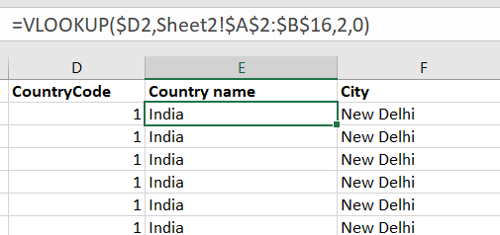

Lookup function was used for populating the country name.

**Question 3-**

**Create a table to represent the number of restaurants opened in each country.**

**Ans.-**

I created a pivot table in excel keeping country names in 1st column and count of restaurant in each country in next columns.

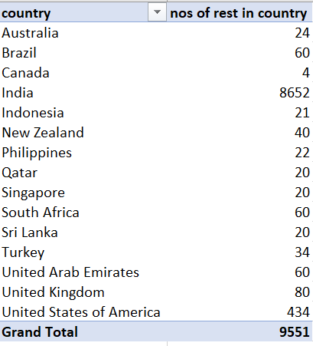

Also simple bar graph chart is been done to visualize it.

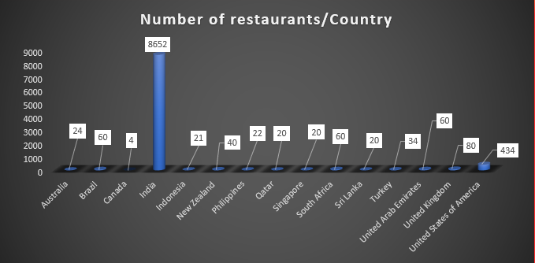

**Question no 4-**

**Also, the management wants to look at the number of restaurants opened in each year, so provide them with something here.?**

**Ans.**

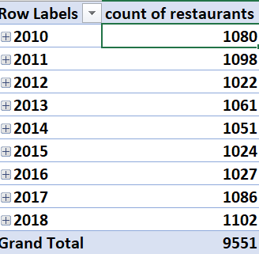

Pivot table is used to get the number of yearly openings of restaurants as well further by adding slicers and filters or as well grouping the dates we can get location that is country or city specific yearly openings as well.

**Questions no.5 –**

**What is the total number of restaurants in India which are in the price range of 4?**

**Ans –**

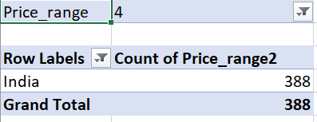

**For** getting the **total number of restaurants in India which are in the price range of 4 I** again used the pivot table and applied 2 filters,1 for price range other for country and it was 388.  
I cross checked it also by the using **countifs** function in the raw sheet. Where one criteria would be country and other would be price range 4.

The syntax of it is following –



This also returned the same number of 388 for restaurants in INDIA with price range 4 .

**Question no 6-**

**According to the data, what is the average number of voters for the restaurants in each country?**

**Ans.**

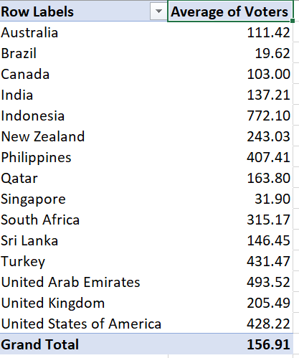

Again, for getting the average number for voters in each country I used pivot table, in which I put names of country in one column and averaged the number of votes as per the country.

Further by applying filter or grouping the data, we can also get the city wise or yearly average of the data.

**Subjective Question-**

**Question no .1**

**Suggest a few countries where the team can open newer restaurants with lesser competition. Which visualization/technique will you use here to justify the suggestions?**

**Changed in resubmission**

**Ans.**

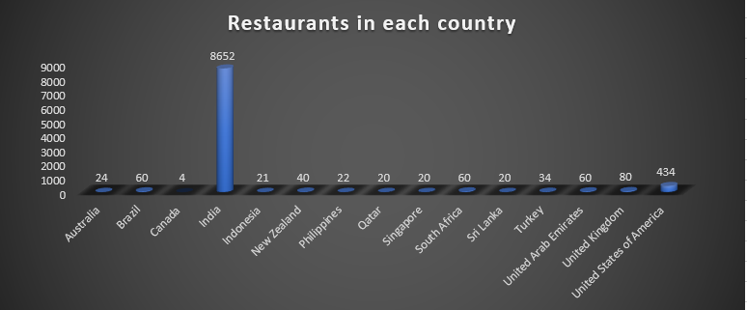

**Distribution of restaurants in all countries**

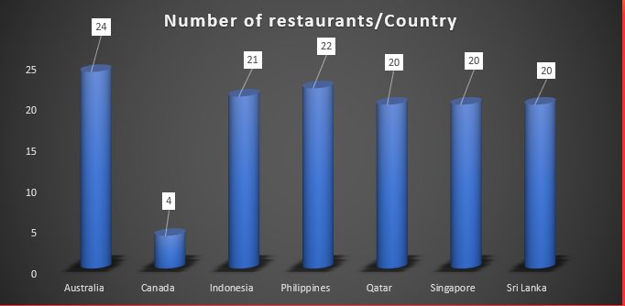

**Countries having lowest count of restaurants comparatively amongst all countries.**

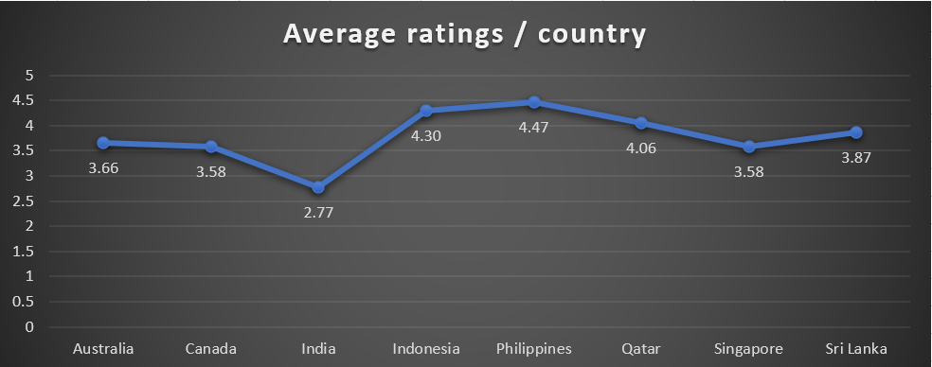

**Average ratings of the countries having lowest count of restaurants.**

* 2 Major criteria to filter the countries that can be looked upon for investments are

Further filtered for preference to which country should be invested in by the criteria of average ratings in those countries.

Distribution of restaurants in countries

* As per the given data, few countries can be filtered out by making pivot table which has currently less restaurants so as we can plan for opening new restaurants with lesser competition.
* As well in the simple bar graph it can be seen the current distribution of the restaurants in each country.
* We excluded the country having a greater number of restaurants like India, USA, UK for sure which already has a good amount of competition already present.

We can see in graph

* **Canada- 4**
* **Qatar -20**
* **Singapore-20**
* **Shri Lanka-20**
* **Indonesia-21**
* **Philippines22**
* **Australia-24**

has lowest number of restaurants as per data.

* From these the average ratings of **Australia, Canada & Singapore ,Shri -Lanka** has the lowest average ratings which provides investors 1st preference for investing.
* **Whereas not considering Quatar,Indonesia, Philippines** on preference for getting a place and chance in market to open newer restaurants. As the restaurants in these countries has high average rating hence for newer restaurants it would be very necessary to keep quality in mind while establishment and would be very competitive to establish in market just on the basis on lowest number of restaurants .
* Strategizing on good quality and services which would return the investor good ratings than which is present in current market in order to achieve profitability.
* Hence, the countries **Australia, Canada, Singapore, Shri -Lanka** having low number or restaurants and low average ratings which can be looked upon as untapped market with a good potential to open new restaurants with less competition.

**On just basis of average ratings**

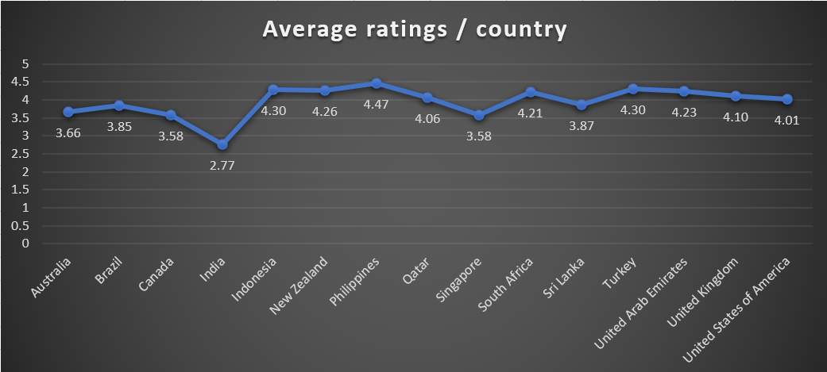

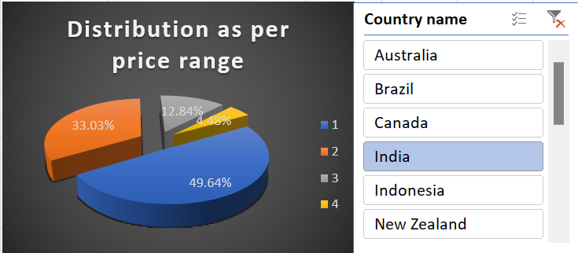

* INDIA based on average ratings falls in the lowest category which means, the existing restaurants in INDIA can have some issues regarding restaurants quality or services in general due to which it has low average ratings.
* However, INDIA already has a large number of existing restaurants in numbers in which almost 50% of restaurants comes in price range of 1 and very minor % comes in high price ratings which means overall 70-80% of restaurants is in medium price range from 1 to 3. But there are large number of existing restaurants in INDIA due to which it can be a tedious task to enter the market.
* So if a newer restaurant is to be planned it has to be made sure to have to be great in terms of quality, taste, service and cuisine factors so as to surpass all the existing restaurants by gaining a high rating.

**Conclusion**

* **Australia, Canada, Singapore, Shri -Lanka, India can be the choice of 1st preference amongst all countries to invest.**

**Question 2**

**Come up with the names of States and cities in the suggested countries suitable for opening restaurants.?**

Name the chart/spreadsheet function you will use for solving the problem.

**ANS**

**Names of states and cities for opening restaurants on 1st preference.**

* For coming up for the names of cities in which new restaurants can be opened parameters that is **number of restaurants in cities and ratings of restaurants in cities, population density in cities** can be used.
* As per the count in **Australia**, other than Hepburn springs every city has only 1 restaurant as per data. However, **Paynesville, Montville, Mayfield** are the cities which has restaurants rated below 3, so if new restaurants with good quality are opened there are higher chances of profit. Also cities other than this which has good population density and tourism can also be assessed for eg. Melbourne, Sydney, Perth.
* As per count in the **Canada**, there are only 1 number of restaurant in each city, so looking upon the ratings, Vineland station has an restaurant rated of average 4.30 that’s why other than vineland station ,**Consort and Yorkton should be the first choice** for opening as because of the comparatively low ratings.
* **In INDIA ,**Cities where existing average ratings are low as well as considering the count of restaurants and votes by people can be looked upon for newer opportunities. Cities like Gaziabad , Faridabad ,New Delhi, Noida having low rating amongst all however the counts of restaurants in these cities are higher therefore there can be a existing gap of service which the existing restaurants are failing to provide if this gap is identified then by leveraging it and providing the identified missing service would give good ratings to restaurants. Tourist city of GOA can also be a good option due to opportunity created by tourism as well there is less number if restaurants but the existing average ratings of those are high hence if newer restaurant is to be opened quality and services should be top notch for surpassing other restaurants. Cities having high population density - Bangalore, Ahmedabad ,Pune , Mumbai can also be looked upon which also has lower counts of existing restaurants can be looked upon but the average ratings of these cities are very high hence care should be taken regarding quality, taste ,services while establishment to surpass the existing restaurants.
* In **Shri Lanka** there are 20 restaurants only in one city which is Colombo, so according to researching on population where there is good number of population like Kandy , Galle, Sri Jayewardenepura Kotte, Trincomalee can be looked upon rather than crowding in Colombo only.

**Names of states and cities for opening restaurants on later preference (cities which we eliminated based on average ratings).**

* As per the count in **Indonesia,** there are 16 restaurants already in Jakarta city also having a good high rating, hence investing in Jakarta is not recommended, other than Jakarta, there is only 1 restaurant in Bandung, so Bandung can be the first option to invest and then Bogor and Tangerang can be looked upon also.
* As per the count in **Philippines, Quezon city & Tagaytay** city has only 1 number of restaurants. Hence these cities can be looked upon.
* In **Quatar,** as the data is comprehensive to Doha, we can look upon other top city’s like Al Rayyan, Al Wakrah, Al Khor etc.

I used pivot table and charts for comparing the number as per needed in excel and online sources for population and exploring the names of cities.

**Conclusion**

**On 1st preference**

* **CANADA** – Consort & Yorkto
* **SRI-LANKA** - Kandy , Galle, Sri Jayewardenepura Kotte, Trincomalee
* **AUSTRALIA** - Paynesville, Montville, Mayfield .
* **INDIA**- Bangalore, Ahmedabad ,Pune , Mumbai ,tourist city like goa, Gaziabad, New Delhi ,Noida ,Faridabad.

**On later preference(just for information)**

* **PHILLIPINES** - Philippines, Quezon city ,Tagaytay
* **INDONESIA** – Bandung , Bogor , Tangerang
* **QUATAR** – Al Rayyan, Al Wakrah, Al Khor

These are the states and cities which are filtered out based on the current numbers of restaurants , population , locations(capital , tourism etc.) where specifically and strategically plans for investment can be done .

**Question 3**

**According to the countries you suggested, what is the current quality in terms of ratings for restaurants that are open there?**

Will you use any aggregation function or a visualization here to solve the problem?

Ans- 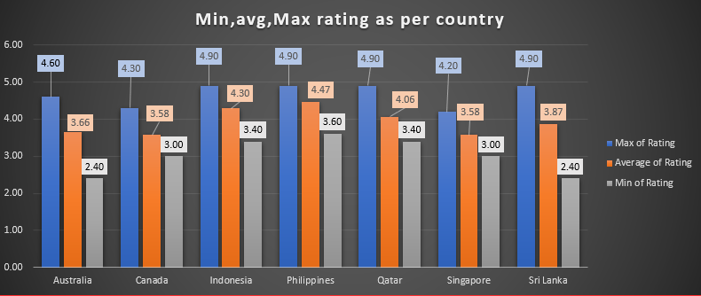

* For assessing the quality based on ratings I made a pivot table in which I calculated minimum, average and maximum ratings for country. From that data I prepared a bar graph.
* For the country I suggested, from the graph we can see currently Philippines and Indonesia has the highest average ratings and Singapore and Canada has the lowest average ratings.
* Indonesia, Philippines, Qatar and Sri Lanka has restaurants having maximum rating of 4.90
* Sri Lanka also have restaurants which has rated lowest that is 2.40 & and Australia also has low rated restaurants of 2.40.

ADDED in resubmission

**Conclusion**

* Based on the average ratings which can be the indicator of current quality terms at the places can gives the idea of what level of services which includes taste of food , presentation of food ,quality of food ,type and quality of ambience etc should be provided to surpass the current restaurants quality so as to gain greater ratings than existing restaurants and be profitable.
* Philippines and Indonesia has the highest average ratings hence to make a successful profitable restaurant here ,the existing level of the services and quality need to be assessed thoroughly and if the same level of services are provided in a price range just below the price range of existing restaurants then by this strategy of providing better services in a lesser price range can get the investors better ratings and profitability .
* It can be comparatively easy to surpass the restaurants with lowest average ratings by just well pre planning and establishing a good restaurants which can be in a slight upper or lower range of price range of existing restaurants making sure the services provided are good in quality and getting good ratings.

For executing this strategy, various techniques from food science and management like pre-planning, planned logistics and support for the food materials, smart menu designing, adding modern facilities like drive way take aways, within time limit delivery orders, big kitchen models etc can be used and profitability can be achieved.

Ans

I used MIN, MAX, AVERAGE aggregation functions to show values as respectively. Due to this we can get a idea of a range rating of restaurants a country has as well by average rating we can get the idea of if a general quality of restaurants a country has.

**Question 4**

**Also, what is the current expenditure on food in the suggested countries, so that we can keep our financial expenditure in control?**

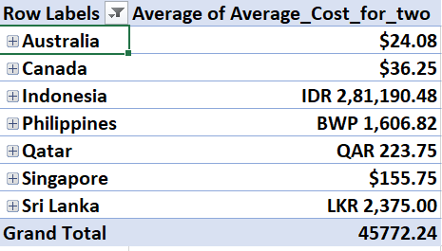

* For an average expenditure, a average of this expenditure on food made by 2 persons at a restaurant can be looked upon.
* For convenience, this individual country wise currency should be converted to any one single currency format so it will be easy for comparison.

For ex. If we covert all values to USD. And prepare a chart for comparison.

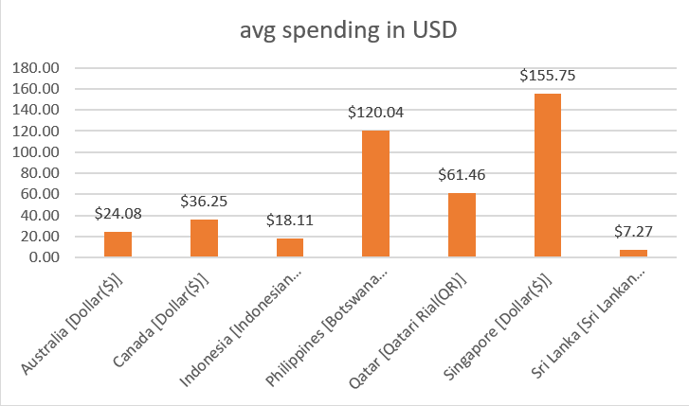

* I averaged the avg. expenditure made by 2 persons using pivot table and by manually converting all the currency made a chart for comparison.

ADDED in resubmission

**Condition in countries where Average expenditure is low**

* Financial expenditure in Sri lanka and Indonesia is the lowest amongst the suggested countries , this can be due to various reasons such as low purchasing power of people, status of general economy, existing price ranges of restaurants and mismatch of it with the earning and spending and purchasing power of population etc.
* Hence while investing in these country with lowest average expenditure it should be kept in mind that pulling the population and earning through it would be a difficult task , hence rather than establishing upper price ranged restaurant with heavy infrastructure it would be beneficial to establishing upon kiosk models with less investment value which will focus just on the extremely important factors of food and time like specific taste and cost cutting in production by using management methods should be done as the profit margin would be very competitive to achieve profitability .

**Condition in countries where Average expenditure is high**

* For the countries like Philippines and Singapore where the average expenditure of people have a good power which means population is ready to pay for the various services like taste of food , presentation of food ,quality of food ,type and quality of ambience etc.
* Hence more creative as well as general services can be provided to people like more creative or a specific to the local likeliness themed ambience, other services can also be provided with more investment initially as the expenditure power of people is good they will use the services and pay for it.
* Profit margin can be kept little high so as to recover investment profitability because population with such expenditure power is ready to pay for the various services which are just not limited to food and taste of it but to a wide scope of hospitality services, ambience services , presentation of food etc.

**Condition in countries where Average expenditure is medium**

* And for the countries where the average expenditure of people is medium, such population values the taste and quality of food more , but also if they get a good deal of overall services in a affordable price range then they are ready to pay more . Hence in countries like Canada and Qatar the investment plans and strategy made should be primarily focused on food and then secondarily focused on other services inclusive of a good and competitive price range price range with a reasonable profit margin in services which is not to high and not to low .

**Question 5**

**Come up with the names of restaurants from the recommended states that are our biggest competitors and also those that are rated in the lower brackets, i.e. 1-2 or 2-3.**

**Ans.-**

In **Australia**, **Paynesville, Montville, Mayfield**

In **Canada** ,**Consort and Yorkton**.

In **Indonesia, Bandung ,Bogor and Tangerang**

In **Philippines, Quezon city & Tagaytay**



* **In Australia**, restaurant in Mayfield named star buffet, having rating 2.9 can be a good competitor as it has a average rating as well cost for 2 is less. Other than this the restaurants has below average profiles not proving to a biggest of competitor.
* Poets Café and Pier 70 lies in the rated lower bracket. I.e Restaurant Poets Café from Monteville has rating 2.4 and Pier 70 has rating 2.6.



* **In Canada**, restaurant in Yorkton & Consort which was suggested for opening of new restaurants, Yorkton has a restaurant named Arigato sushi having a good rating of 3.3 as well as the avg cost for 2 is reasonable can be a good competitor for new restaurant opening.
* The restaurant in Consort does not has a good number of votes as well the rating is lowest in the Canada region so consort restaurant cannot be a good competition.
* Consort restaurant, lie in the lower rated bracket of 2-3.

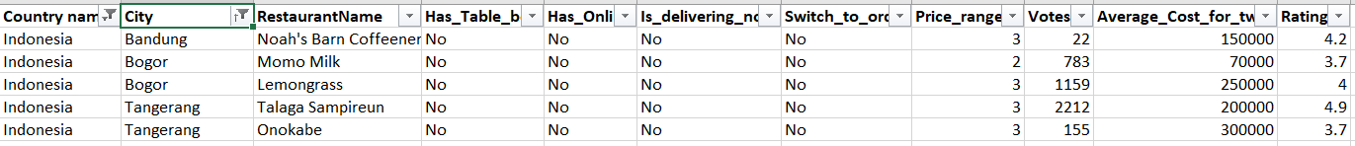

* **In Indonesia**, In bandung, nominal competition is there as the Noah’s barn Coffernery has a above avg profile.
* In Bogor, Lemongrass can be a biggest competition,as it lies in a average to above average price range as well, has good number of votes and a good rating of 4.
* In Tangerang, Talaga Sampireun is the biggest restaurant as it has the highest rating of 4.9 and in a good price range.
* No restaurants lie in the lower rated price ranges in Indonesia within suggested cities.



* In **Philippines**,in both of the suggested cities, there is a strong competition.
* The restaurant in Tagaytay city named Balay Dako and Quezon City named Silantro Fil-Mex has high rating of 4.5 and 4.8 that too within a good price range.
* No restaurant comes in lower rated bracket in suggested cities.
* The restaurants which are in high ratings are the biggest competitors for the newer restaurants investors planning to open, however using the knowledge as the rating is the indicators of quality we can study upon the model, plans, strategy ,food style etc of the restaurants which has high ratings as a reference to our planning which will benefit .
* We can incorporate the ideas and techniques or the quality reference which these restaurants with high ratings are using and understanding the references and plans if in the new restaurants we incorporate and even if we can provide a better package in the same price point or if possible, a slightly lesser price point would be a great added advantage in achieving profitability.
* By analysing the information about the restaurants existing in lower brackets, we would know the difference between the services they are offering and what the population wants .
* This difference is the reason for the low rating of the restaurants and when identified the difference and the things are provided in the newer planned restaurants with the services difference which was not provided in the low rated restaurants would be point of getting greater ratings and as well profitability.

**Question 6**

**Which cuisines should we focus on in the newer restaurants to get better feedback? Does the choice of cuisines affect the restaurant ratings?**

Ans.

* As per the data analysis from excel sheet subjective que 5-
* We can see that cuisines of food which is present in higher rated restaurants are also present in lower rated restaurants too throughout the countries.
* Due to this pattern, we can conclude that there is no direct relationship between cuisines and restaurant ratings and the choice of cuisines has not affected directly due to cuisines being offered in the data set.
* For example. In Australia the modern Australian cuisine is present in both lower rated as well as higher rated restaurants hence it proves that the service, quality and taste matters more than just the choice of cuisines.

Added in resubmission

* As the data set suggest , in numerous cases , the cuisines which are present in lower rating are also present in higher rating restaurants which indicates that its not the cuisine choice alone which depends upon the rating and if with a good quality same things is provided then it can achieve a good rating For example.
* In Australia the modern Australian cuisine is present in both lower rated as well as higher rated restaurants, so by assessing and analysing that what is the issue or difference with the food items of the cuisines which are present in both high and low rated restaurants and incorporating that differences with price range kept in mind in our newer opened restaurants can help us in the cuisine choice.
* **Conclusion**
* Hence while planning for cuisine , we can figure out the set of cuisines which works for the most of the population in the locality and is generally appropriate according to the taste and choices of the population, that is we cannot place a extremely spicy cuisine in a English locality as they are not use to it ,hence after appropriate selection of cuisine set the attributes like what is short in the same cuisine in lower rated restaurant and what is being provided in the higher rated restaurant this difference should be incorporated and such the cuisine should be planned which would achieve the investor good ratings and customer satisfaction return good overall profitability.

**Question 7**

According to our current data, should we go for online delivery and table booking? Does that affect the customer’s ratings?

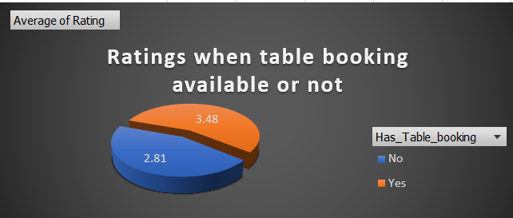

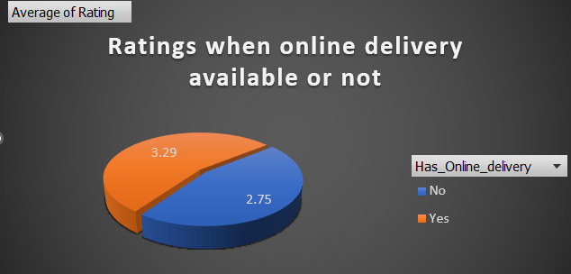

* Data of weather the restaurant has options of table booking or not and weather the restaurant has options of online delivery or not is analysed for observing its effect on ratings.
* It can be seen that , fluctuation of difference is there in both the cases that is when there is option of table booking the average rating found out to be 3.48 compare to when there is not which is 2.81.
* As well if the restaurant has option available for delivering online the average ratings found out to be is 3.29 and compared to when the restaurant doesn’t delivers only which is 2.75.

**Conclusion**

* Hence is can be concluded that difference is there when the restaurants choses to keep the options of table bookings and online delivery open vs close.
* Hence it can be recommended to keep the option of table booking and online delivery open in the newer restaurants planning to be opened. And **YES we should definitely go for option of online delivery and table booking.**

**Strategy for availing online services**

* Online services like online delivery and table booking are the newer trends and addition in the services. In earlier times however table booking used to exist in higher priced restaurants but online delivery and order is newer to the market trend.
* However , these services drastically enhance the convenience from a customer point of view and in today’s world these options of table booking and online ordering and delivery are not in option but a necessary requirement.
* To avail these options in the newer opened restaurants there are various options in market like to collaborate with a online services providing company , to open a online portal by self by restaurants providing these services but the issue is the new restaurant will also have to arrange and collaborate with logistics support as a third party alliance whilst if the restaurant direct collaborate with a such online service provider would be less of a hassle for the management time by just paying a little percentage of charge to the online service provider .
* Online delivery has various aspects to be taken care of which are , the ease of order for customer , online marketing, timely delivery , packaging of order etc , these aspects comes with the management of time and money which is to be controlled .

**Question 8**

**Should the team keep the rate of cuisines higher? Will that affect the feedback? According to our data are the rates of cuisines and ratings, correlated?**

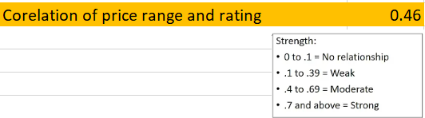

* On corelating the array of price ranges and ratings the corelation between them were found out to be positive that is if the price range increases there is chance of increase in ratings as well and vice versa.
* However, the strength of relationship, is a moderate relationship. As well on observing the data there are same type of cuisines which are lower in some restaurants and higher in some restaurants depending upon the restaurants.

**Conclusion**

* As it can be seen it is a moderate relationship between price range and ratings we can conclude that, yes the more the price range it can affect the taste, services, etc of the cuisines and experience as the higher rates will allow the owners of the business to provide more to customers and in result it affects the ratings.

**Question 9**

**What is the distribution of several restaurants of different price ranges in all the countries?**

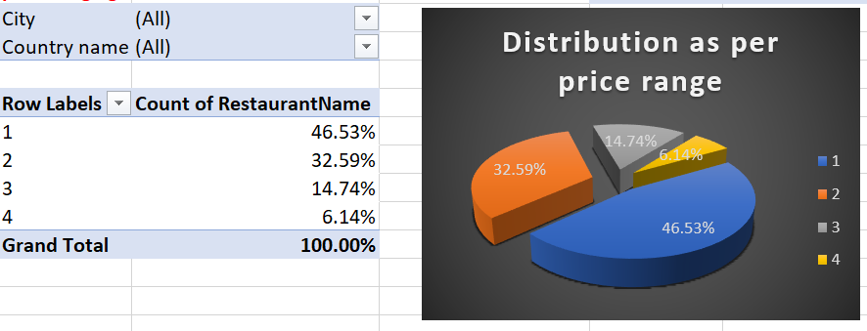

**There are 46.53% restaurants amongst price range of 1**

**There are 32.59% restaurants amongst price range of 2**

**There are 14.74% restaurants amongst price range of 3**

**There are 32.59% restaurants amongst price range of 4**

**I made a pivot table in which I grouped the pivot table and changed the show values as option to show as percentage of grand total by which it gets easy to compare the distribution.**